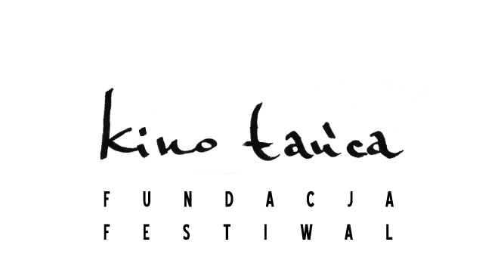

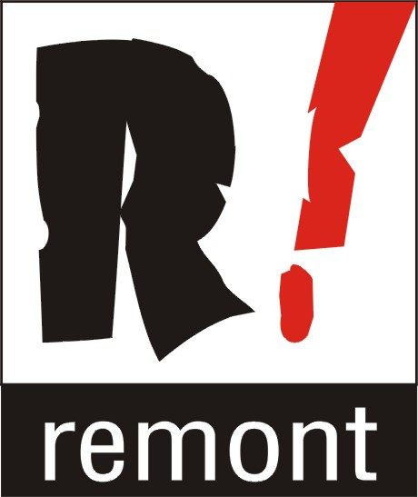Klub Studencki Remont w Warszawie, ul. Waryńskiego 12 (metro POLITECHNIKA)
www.remont.klub.waw.pl

12 – 13 CZERWCA 2007

w ramach VII OGÓLNOPOLSKIEGO FESTIWALU
TAŃCA WSPÓŁCZESNEGO POLEMIQI 2007

12 czerwca, godz. 19.00
Minou Wielka Brytania 2002 reż. Magali Charrier, chor. Maria Lloyd, prod. South East Dance Agency / 6 min
+ nagroda Best Screen Choreography na IMZ dance screen Festival 2002 w Monaco

źródło www.imz.at

Minou, a young woman in her 20s, lives an apparently ordinary life inside the four walls of her flat. To survive the monotony and the solitude of her daily activities, Minou has filled her head with romantic stories and her flat with imaginary friends: toy friends, pet friends, eclectic objects collected here and there, and cherished like the friends, lovers and family that she's never had. When a plumber comes to work in her apartment on that day, it disturbs Minou’s carefully arranged world and brings her traumatically back to reality. As the plumber enters Minou’s flat he meets with her imaginary friends… and what if he was to understand them and, through them, Minou herself? Could this be the beginning of a real love story?

Will time tell? Australia / Japonia 2006 reż. Sue Healey, zdj. Mark Pugh / 12 min.

A new dance-video project Will Time Tell? created by Sue Healey and cinematographer Mark Pugh. This series has a focus on time and timing - an investigation into the puzzles and paradoxes of this slippery subject. The work will involve a collaboration between two Japanese and two Australian performers. A site specific installation work will also be created and performed in both countries.

Blush Belgia 2005 reż. l chor. Wim Vandekeybus, taniec CCCP, muz. David Eugene Edwards, prod. CCCP, Sciapode, Ultima Vez / 52 min.
+ nominacja do nagrody Best Camera Re-work na IMZ dance screen Festival 2005 w Brighton

O Blush, źródło www.ultimavez.com

After having discovered the medium of film during the registration of his first performances (for the dance videos Roseland and La Mentira – both directed by Wim Vandekeybus, Walter Verdin and Octavio Iturbe), Wim Vandekeybus directed his first short film Elba and Federico in 1993. This film became the basis for the production Her Body doesn't fit her soul.
From this moment onwards film became a constant value in Wim's work; an extra outlet for his wild imagination, an important and essential element in his performances. Wim Vandekeybus barely makes performances without integrating the medium of film. More recent short-films such as The Last Words and Inasmuch… were not only inherent parts of the performances; they also lead their life the art and short film circuit.
Besides the short films and film and video fragments that are part of the performances, Wim Vandekeybus has directed several video adaptations of his dance productions. By putting elements of his performances in other contexts and locations, Wim Vandekeybus gives them a totally new dynamic and rhythm.
In May and June of 2004 Wim Vandekeybus shot a 52-minute feature based on his successful performance Blush. Carried by the music of David Eugene Edwards and Woven Hand and with texts by the Flemish author Peter Verhelst, Blush is a dazzling voyage swinging between the heavenly landscapes of Corsica
and the slummiest depths of Brussels.
It is an exploration of the savage subconscious, of mythical forests, of conflicting instincts, of imagination, where the body has reasons unknown to the mind. In dance sequences of attraction, confrontation and repulsion the performers take on animal metamorphoses…

Blush was selected for the ACID-Programme (Agence du Cinéma Indépendent pour sa diffusion) at the Film festival of Cannes 2005. The DVD release will follow the French cinema release in December 2005.

Written & directed by Wim Vandekeybus
Photography Lieven Van Baelen
Editing Dieter Diependaele
Original music David Eugene Edwards
Sound design Charo Calvo
Sound supervisor Benjamin Dandoy
Costume design Isabelle Lhoas
Dialogues Peter Verhelst & Ultima Vez
Created with & performed by Laura Arís Alvarez, Elena Fokina, Jozef Frucek, Ina Geerts, Robert M. Hayden, Germán Jauregui Allue, Linda Kapetanea, Thi-Mai Nguyen, Thomas Steyaert, Wim Vandekeybus
Also featuring David Eugene Edwards, Daniel McMahon, Ordy Garrison, Shane Trost
Produced by Bart Van Langendonck, Emilie Blézat, Ellen De Waele
Executive producers Ruben Goots, Ellen De Waele
Coproduction CCCP (Brussels), Sciapode (Paris), Ultima Vez (Brussels)
With the support of het Vlaams Audiovisueel Fonds (VAF), le Centre National de la Cinématographie (CNC), Le Fresnoy – Studio national des arts contemporains, ADAMI, Collectivité Territoriale de Corse & France 3 Corse,
Telesonne, Image Plus

13 CZERWCA, godz. 19.00
One Flat Thing, reproduced Francja 2006 reż. Thierry de Mey, chor. William Forsythe taniec: The Forsythe Dance Company, muz. Thom Willems, prod. Nada, MK2, Charleroi/Danses
In autumn 2005 Thierry de Mey directed a new film, One Flat Thing, reproduced with the collaboration of choreographer William Forsythe (MK2 (Paris) and Forsythe Foundation (New York) production), based on one of the choreographer's master piece, One Flat Thing. This film was also broadcasted by Arte in 2006.
William Forsythe carved a formidable career in Europe with infrequent returns to NYC. His collaboration with Thierry de Mey, acclaimed for his screen adaptations of works by Anna Teresa de Keersmaeker, brings us insights into his ingenious choreography. Thierry de Mey follows a formal strategy to capture “the play of triggers, moments of waiting, visual and sonic cues, and to follow the conducting voices of Forsythe’s choreographic melodic montage and contrasting mounting rhythms that penetrates inside the playing space.
wiecej na:
http://www.charleroi-danses.be/Public/DossierSpectacle.php?ID=1982&child1=1831&page=1&language=eng

